
A SKILL BASED EVALUATION REPORT
SUBMITTED BY
SANTHOSH K (URK24CS1047)
COURSE CODE
23CS2048
COURSE NAME
WEB TECHNOLOGY
OCTOBER 2026

DIVISION OF COMPUTER SCIENCE AND ENGINEERING
SCHOOL OF COMPUTER SCIENCE AND TECHNOLOGY

YOGA CLASS BOOKING SYSTEM
A REAL TIME APPLICATION REPORT
Submitted by
SANTHOSH K (URK24CS1047)
DIVISION OF COMPUTER SCIENCE AND ENGINEERING
KARUNYA INSTITUTE OF TECHNOLOGY AND SCIENCES
(Declared as Deemed-to-be-under Sec-3 of the UGC Act,
1956) Karunya Nagar, Coimbatore - 641 114. INDIA
OCTOBER 2026

ABSTRACT
Serenity Yoga – Yoga Class Booking System is a full-stack web application that allows members of a yoga studio to browse classes, reserve a spot and manage their bookings online, while the studio administrator manages the class schedule through a dashboard. It replaces manual, phone-based booking with a real-time system that always shows how many spots are left in each class.
Visitors can view a two-week class schedule grouped by day and filter it by yoga style, level, date or keyword. Each class has a details page showing the instructor, timing, duration, location, price and live availability. Registered members book a class with one click, view their bookings under Upcoming, Past and Cancelled tabs, and cancel an upcoming booking after confirmation. The administrator views studio statistics such as members, active bookings, occupancy and revenue; creates, edits and deletes classes; and views or removes the attendees of each class.
Database integration: The application stores its data in MongoDB Atlas, a cloud-hosted MongoDB cluster, in the yoga_booking database, accessed through the Mongoose ODM. Three collections are used: users, yogaclasses and bookings. Bookings reference users and classes by ObjectId, a unique compound index prevents duplicate bookings, and an aggregation pipeline counts confirmed bookings to calculate the seats left in each class.
Frontend (UI): The user interface is a single-page application developed using HTML5, CSS3, JavaScript (ES6+) and React 18 with Vite. It uses React Router for client-side routing and protected routes, the Context API for authentication state and notifications, custom hooks for reusable booking logic, and a responsive layout built with CSS Grid, Flexbox and media queries. Forms are validated on the client side before submission.
Backend (server): The backend is a RESTful API developed using Node.js and Express.js. It applies middleware for CORS, JSON parsing, JWT-based authentication and role-based authorisation of admin routes. Passwords are hashed with bcrypt, configuration is loaded from a .env file, and all inputs are validated again on the server. Business rules such as seat capacity, duplicate bookings and past-class restrictions are enforced, and errors are returned with appropriate HTTP status codes. The frontend communicates with the API using the Fetch API and JSON.

SAMPLE OUTPUT SCREENSHOT
UI Design
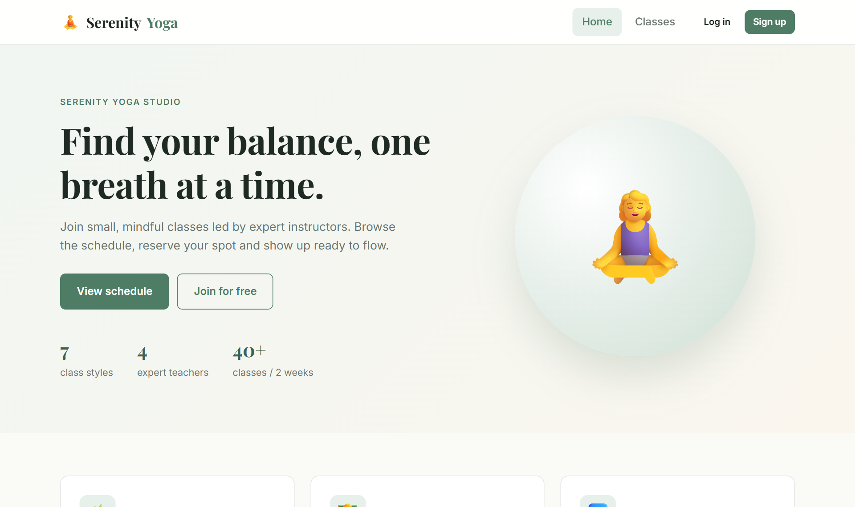  Fig. 1: Home Page | 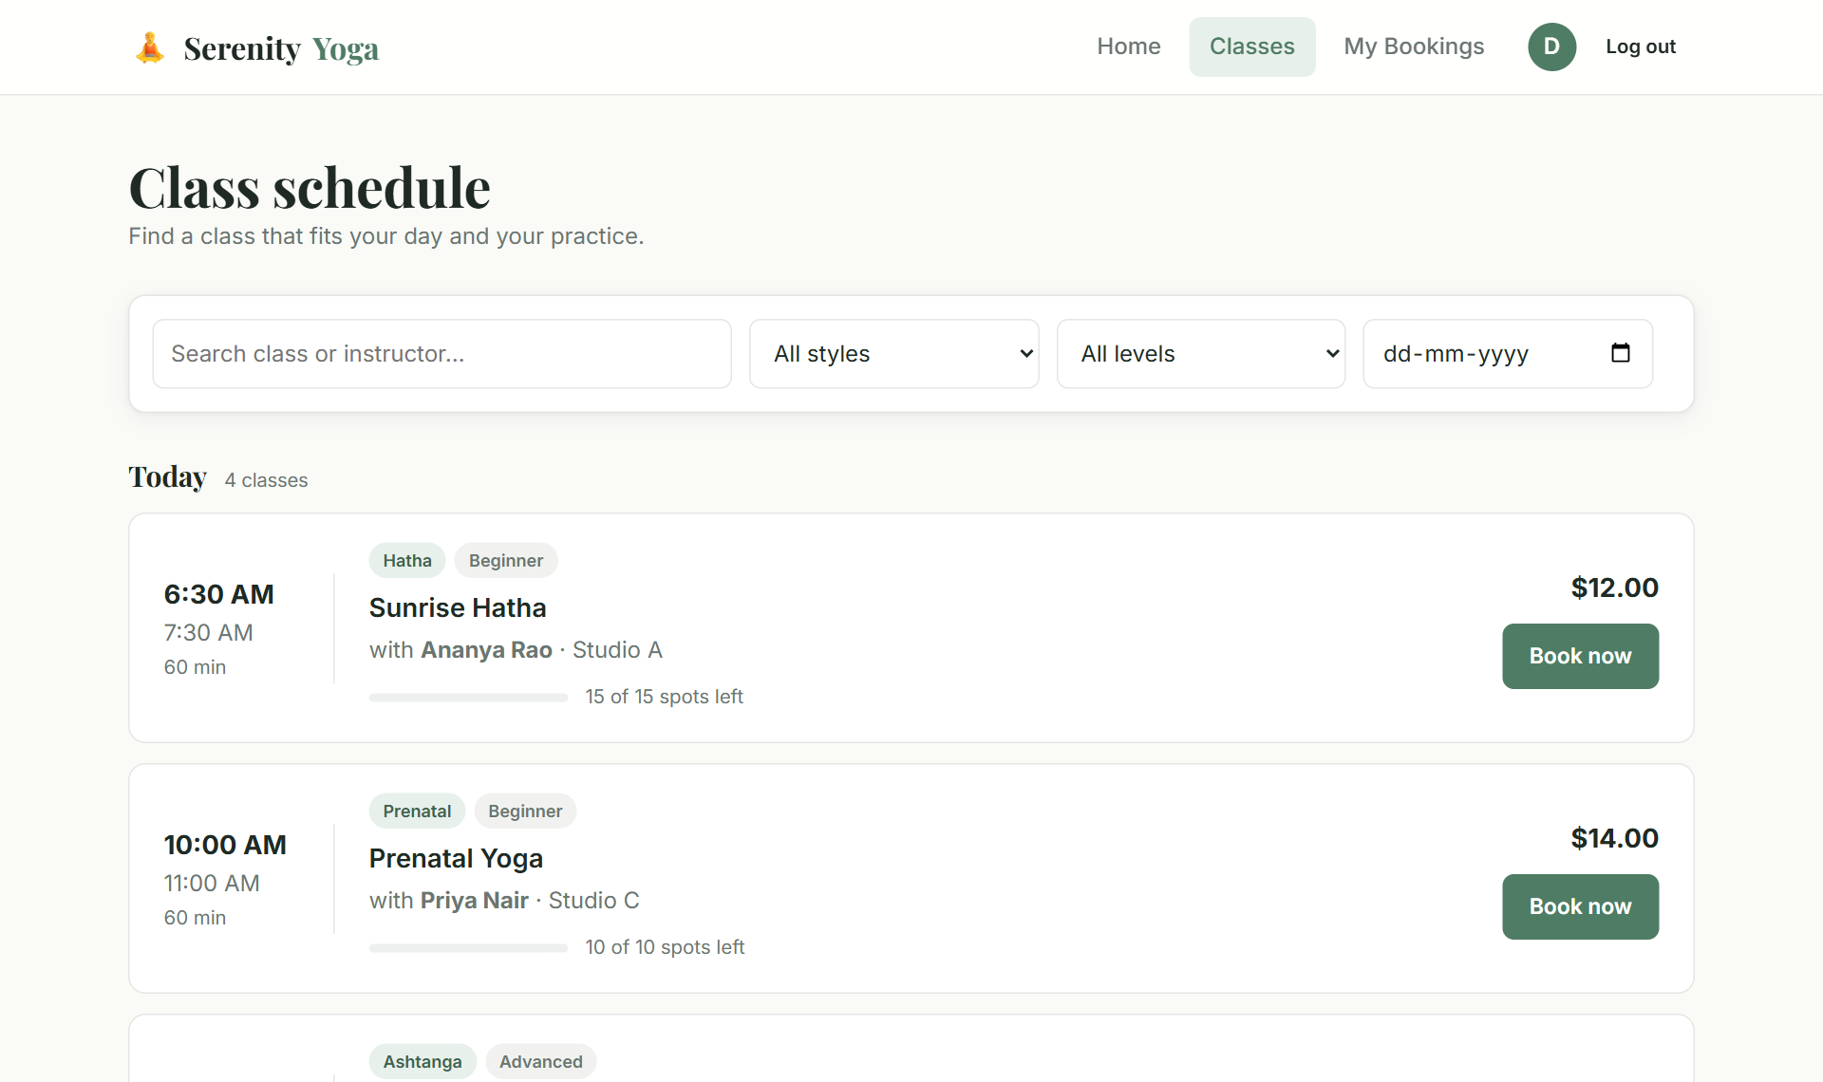  Fig. 2: Class Schedule with Filters
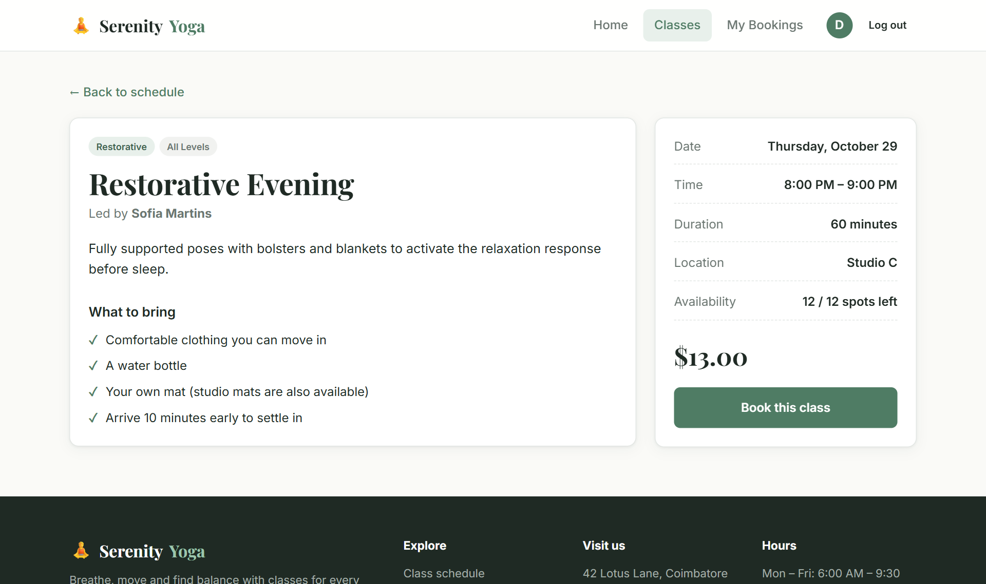  Fig. 3: Class Details and Booking | 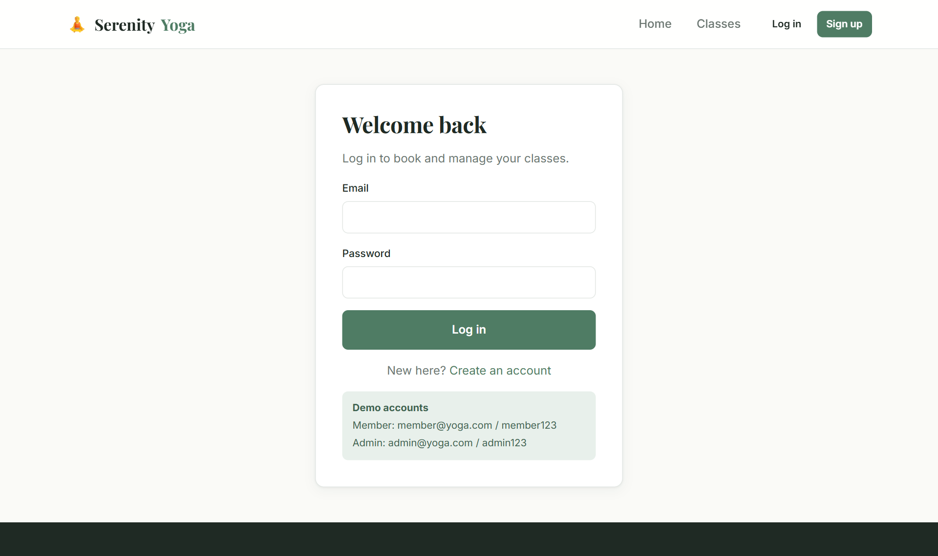  Fig. 4: Member Login
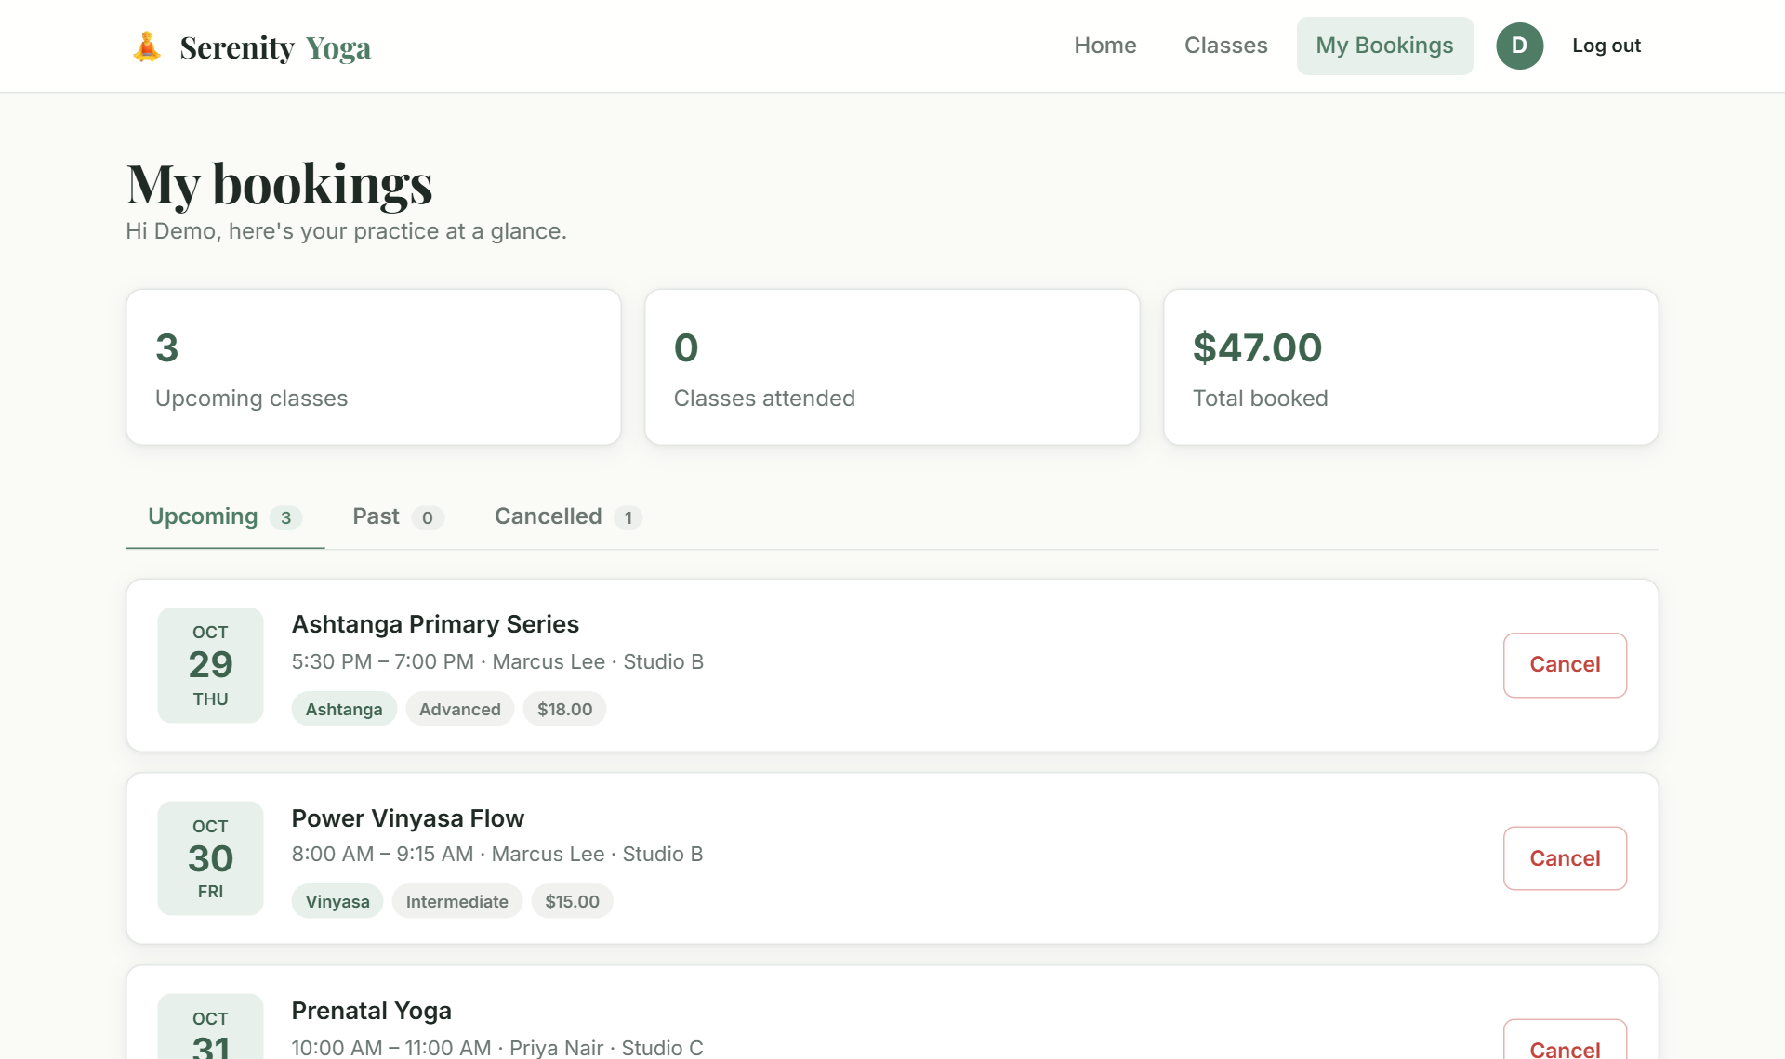  Fig. 5: My Bookings (Member) | 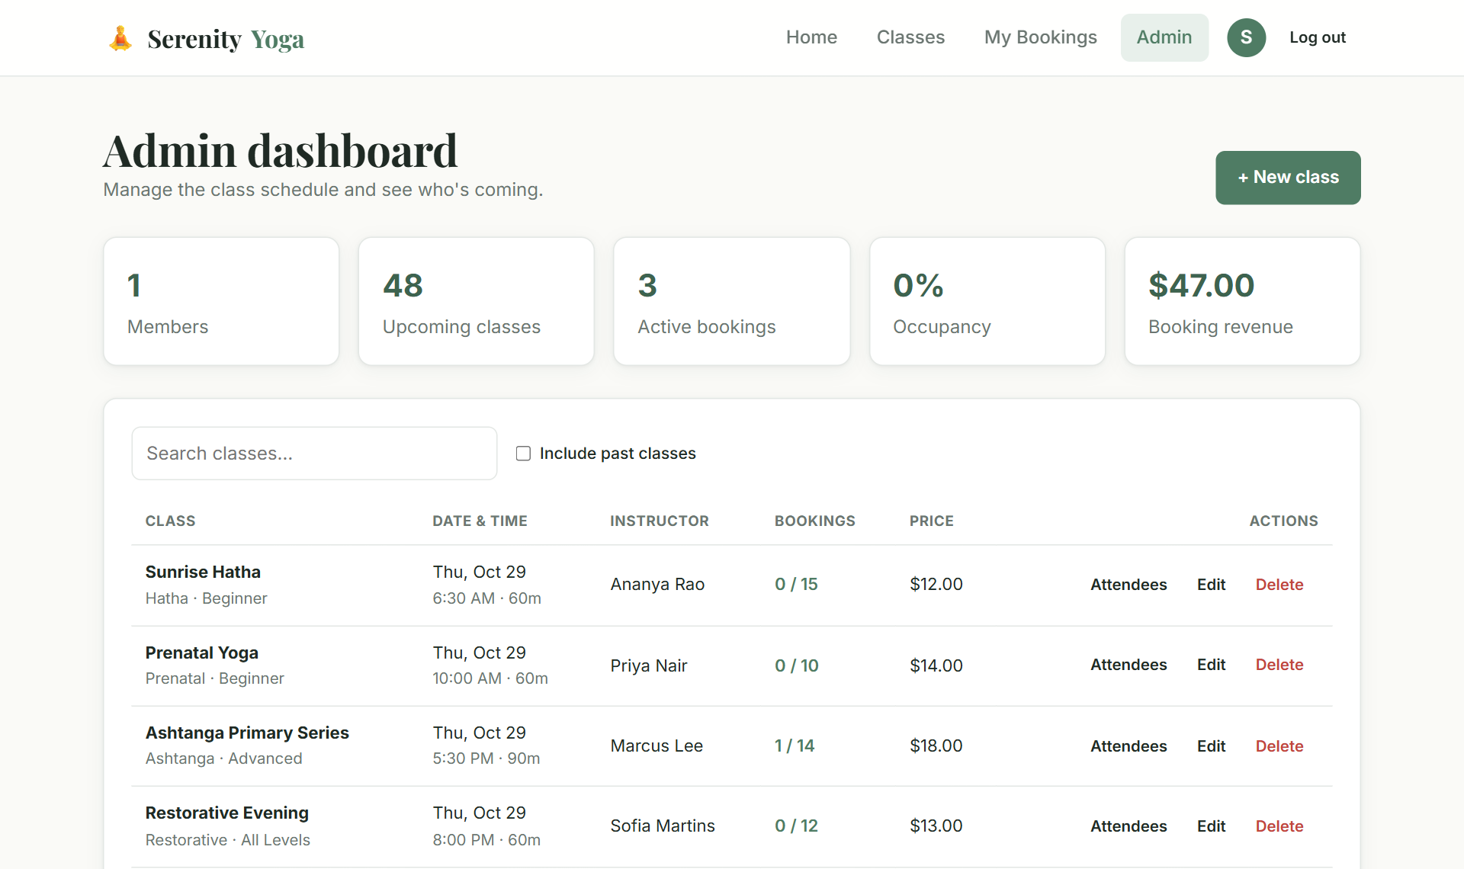  Fig. 6: Admin Dashboard

MongoDB Database Storage
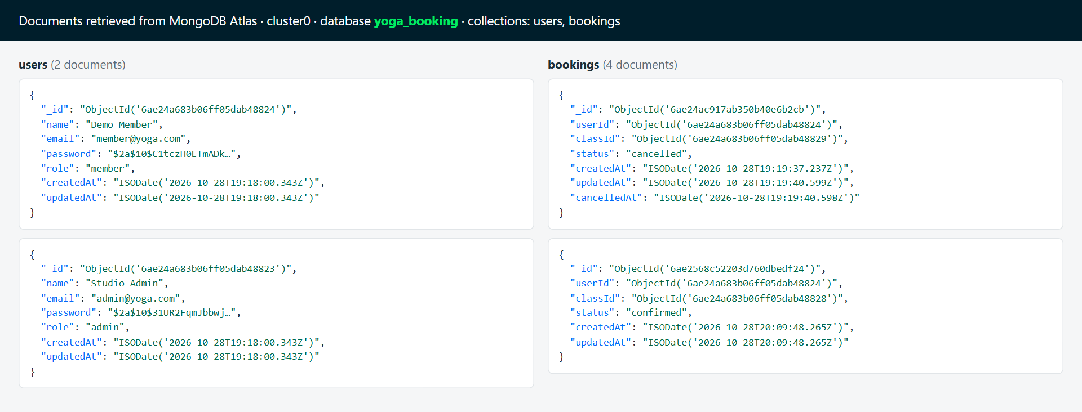
Fig. 7: users and bookings collections – yoga_booking database (MongoDB Atlas)
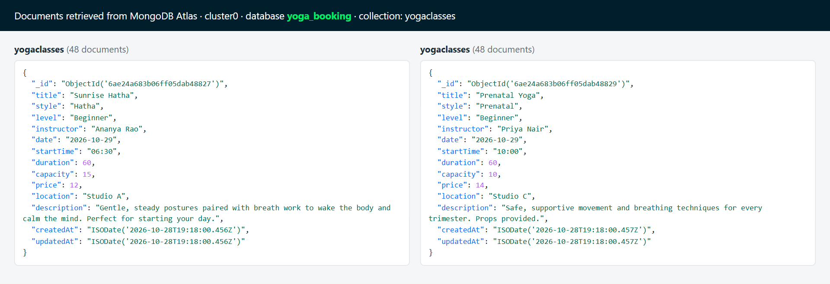
Fig. 8: yogaclasses collection – yoga_booking database (MongoDB Atlas)

EVALUATION SHEET
Reg.No : URK24CS1047
Name : SANTHOSH K
Course code: 23CS2048
Course Name: Web Technology

S.No | Rubrics | Maximum  Marks | Marks  Obtained
1 | Hackathon | 20
2 | Project – Case Study | 20
Total |  | 40

Rubrics | Excellent (4) | Good (3) | Average (2) | Below Average  (1)
Design of
Website
(4 Marks)
Input Validation
(4 Marks)
Integration of
Frontend and
Backend
(4 Marks)
Presentation
and Viva
(4 Marks)
GitHub
Repository
(4 Marks)
Signature of the Faculty-in-charge

